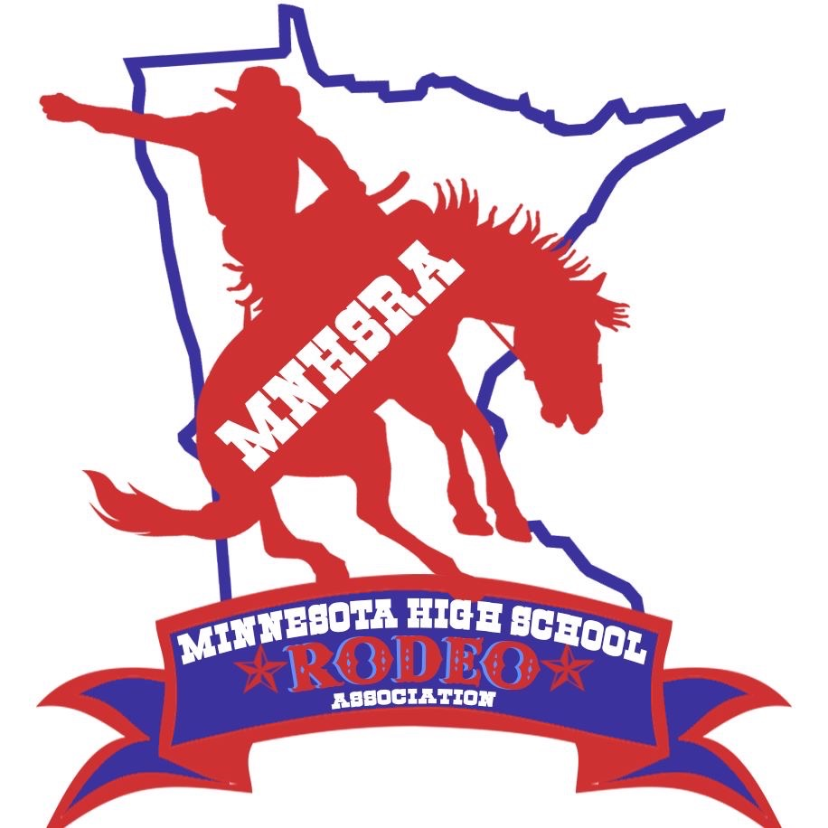RCH #1-4 Fall 2024
RCH #1 & 2 September 14th & 15th
RCH #3 & 4 December 7th & 8th
Minnesota Equestrian Center
24621 Gilmore Valley Rd
Winona, MN 55987

Entries for HS RCH #1 & 2 close Monday night 9/2/2024 at midnight.
Late Entries close Thursday night 9/5/2024 at midnight.
Draw Outs close Monday 9/9/2024 at midnight.

Entries for HS RCH #3 &4 close Monday night 11/25/2024 at midnight.
Late Entries close Thursday night 11/28/2024 at midnight.
Draw Outs close Monday 12/2/2024 at midnight.

~The HS RCH is held with the North Central Reined Cow Horse Association. The HS RCH will go near the end of the show on Saturday and the same for Sunday. This is usually late afternoon into the evening.

~Need to enter online thru the MNHSRA website (like all the region rodeos) and we also ask that you go online to the website www.ncrcha.com and enter the HS rodeo class for both Saturday and Sunday and reserve your stall. (Stalls are required)
~Patterns will be available at check in on Saturday.
*We can not guarantee there will be any RCH offered in the spring (other than the State Finals)* The state only neds to offer 3 all year. Contestants need to enter and compete in 3 rounds to be eligible for state finals.

