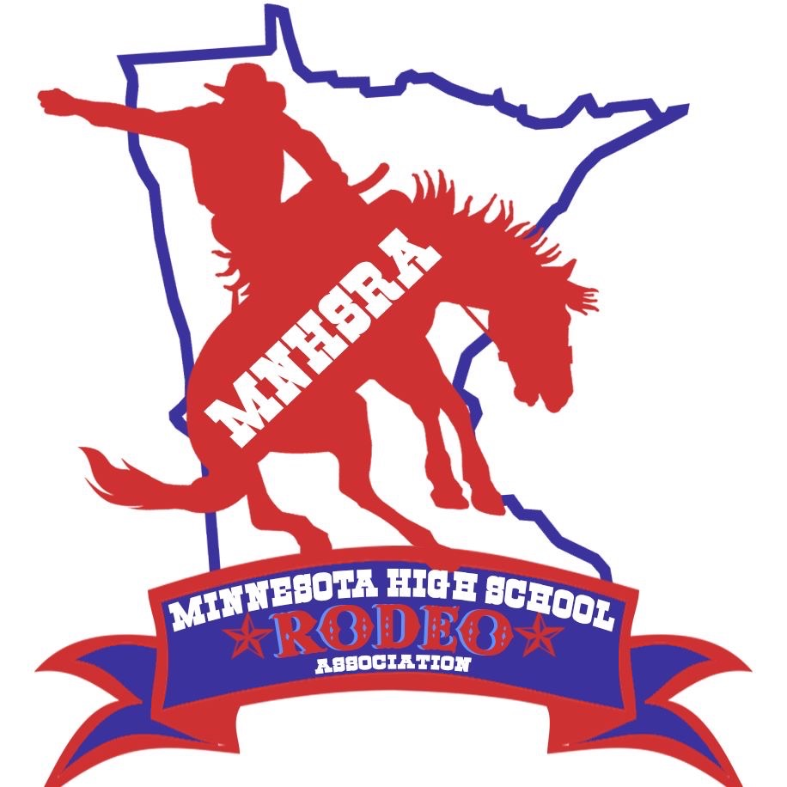Cutting #7 & 8 Spring 2025
April 18th
Simons Arena
29100 Harry Ave
Cannon Falls, MN 55009

Entries close Monday 4/7/2025 at midnight.
Late Entries close Thursday 4/10/2025 at midnight.
Draw Outs close Monday 4/14/2025 at midnight.

The HS Cutting is held with the North Central Reined Cow Horse Association

The HS Cutting will go twice on Friday April 18th.

~Need to enter online thru the MNHSRA website (like all the region rodeos) and we also ask that you go online to the website www.ncrcha.com to reserve your stall. (Stalls are required)
Contestants need to enter and compete in 3 rounds to be eligible for state finals.

