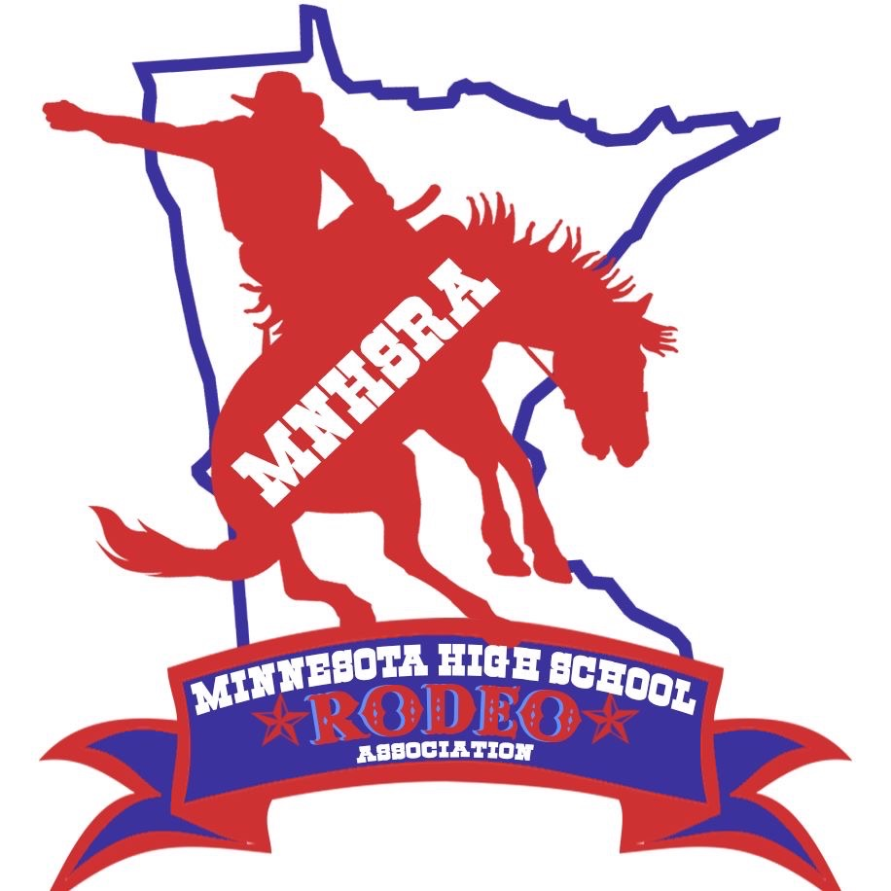Cutting State Finals 2025
June 6, 7, 8th
^{Owatonna}
^{Address to come}

Entries close Monday 5/26/25 at midnight.
Late Entries close Thursday night 5/29/25 at midnight.
Draw Outs close Monday 6/2/2025 at midnight.

The HS Cutting is held with the Minnesota Cutting Horse Association.

Contestants need to enter and compete in 3 rounds to be eligible for state finals.

