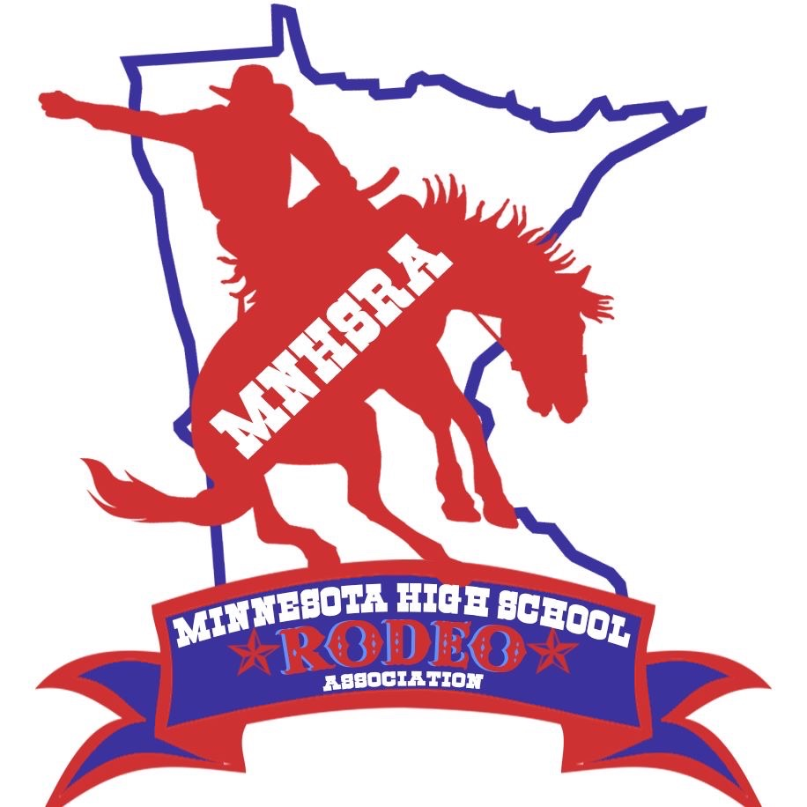RCH State Finals 2025
April 18-19th
Simons Arena
29100 Harry Ave
Cannon Falls, MN 55009

Entries close Monday night 4/7/2025 at midnight.
Late Entries close Thursday night 4/10/2025 at midnight.
Draw Outs close Monday 4/14/2025 at midnight.

The HS RCH is held with the North Central Reined Cow Horse Association.
1st Go on Friday (afternoon/evening) April 18th
2nd Go on Saturday April 19th
Short Go on Saturday April 19th
~Need to enter online thru the MNHSRA website (like all the region rodeos) and we also ask that you go online to the website www.ncrcha.com to reserve your stall. (Stalls are required)
~Patterns will be available at check.
Contestants need to enter and compete in 3 rounds to be eligible for state finals.

