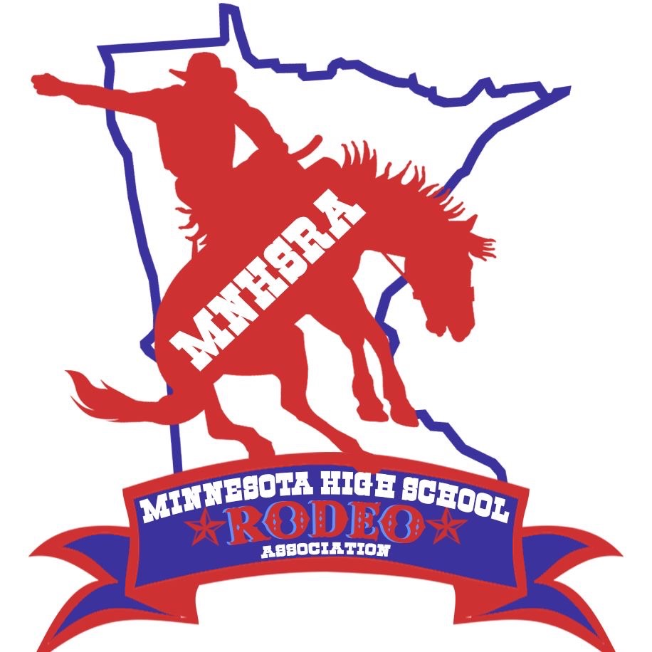Cutting State Finals 2025
June 6th & 7th
^{Owatonna}
^{Steele County Fairgrounds}

Entries close Monday 5/26/25 at midnight.
Late Entries close Thursday night 5/29/25 at midnight.
Draw Outs close Monday 6/2/2025 at midnight.

The HS Cutting is held with the Minnesota Cutting Horse Association. Producer is 57 Ranches

Friday June 6th -1st and 2nd Go
Saurday June 7th- Short Go
For Stalls contact:
JP 701-640-0451
Kurt 763-350-7358
Contestants need to enter and compete in 3 rounds to be eligible
for state finals.

